**Images Created by Ikko**

Ikko Ehode Arimoto 2023, *Attacker*, created 04/03/2023 for BENV1043 Multimedia in Design Presentation, T1 2023



Ikko Ehode Arimoto 2023, *Defender*, created 04/03/2023 for BENV1043 Multimedia in Design Presentation, T1 2023

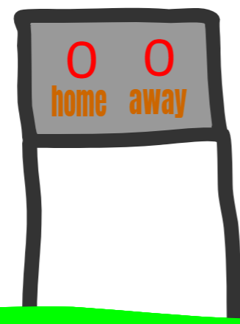

Ikko Ehode Arimoto 2023, *Score Board*, created 05/03/2023 for BENV1043 Multimedia in Design Presentation, T1 2023

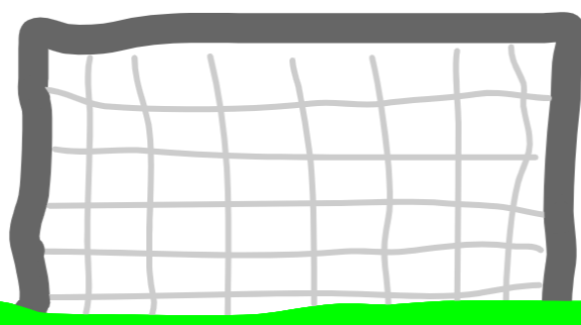

Ikko Ehode Arimoto 2023, *Goal*, created 05/03/2023 for BENV1043 Multimedia in Design Presentation, T1 2023



Ikko Ehode Arimoto 2023, *Teammate*, created 07/03/2023 for BENV1043 Multimedia in Design Presentation, T1 2023

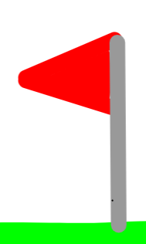

Ikko Ehode Arimoto 2023, *Corner Flag*, created 07/03/2023 for BENV1043 Multimedia in Design Presentation, T1 2023